**Exercise 1: Singleton pattern implementation**

**Solution code:**

**Logger.java:**

package singleton;

public class Logger {

private static Logger instance;

private Logger() {}

public static Logger getInstance() {

if (instance == null) {

instance = new Logger();

}

return instance;

}

public void log(String message) {

System.out.println("Log: " + message);

}

}

**Main.java:**

package singleton;

public class Main {

public static void main(String[] args) {

Logger logger1 = Logger.getInstance();

Logger logger2 = Logger.getInstance();

logger1.log("First message");

logger2.log("Second message");

System.out.println("Same instance: " + (logger1==logger2));

}}

**Output:**

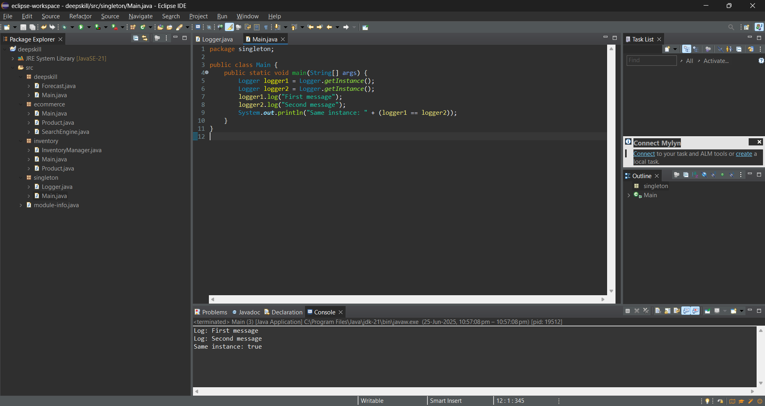

**Exercise 2: Factory method pattern**

**Solution code:**

**Project structure(Internal):**

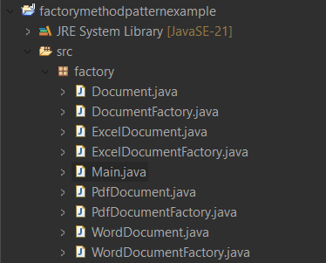

**Document.java(Interface):**

package factory;

public interface Document {

void open();

}

**WordDocument.java:**

package factory;

public class WordDocument implements Document {

public void open() {

System.out.println("Opening Word Document");

}

}

**PdfDocument.java:**

package factory;

public class PdfDocument implements Document {

public void open() {

System.out.println("Opening PDF Document");

}

}

**ExcelDocument.java:**

package factory;

public class ExcelDocument implements Document {

public void open() {

System.out.println("Opening Excel Document");

}

}

**DocumentFactory.java (Abstract):**

package factory;

public abstract class DocumentFactory {

public abstract Document createDocument();

}

**WordDocument.java:**

package factory;

public class WordDocumentFactory extends DocumentFactory {

public Document createDocument() {

return new WordDocument();

}

}

**PdfDocumentFactory.java:**

package factory;

public class PdfDocumentFactory extends DocumentFactory {

public Document createDocument() {

return new PdfDocument();

}

}

**ExcelDocumentFactory.java:**

package factory;

public class ExcelDocumentFactory extends DocumentFactory {

public Document createDocument() {

return new ExcelDocument();

}

}

**Main.java:**

package factory;

public class Main {

public static void main(String[] args) {

DocumentFactory wordFactory = new WordDocumentFactory();

Document wordDoc = wordFactory.createDocument();

wordDoc.open();

DocumentFactory pdfFactory = new PdfDocumentFactory();

Document pdfDoc = pdfFactory.createDocument();

pdfDoc.open();

DocumentFactory excelFactory = new ExcelDocumentFactory();

Document excelDoc = excelFactory.createDocument();

excelDoc.open();

}

}

**Output:**

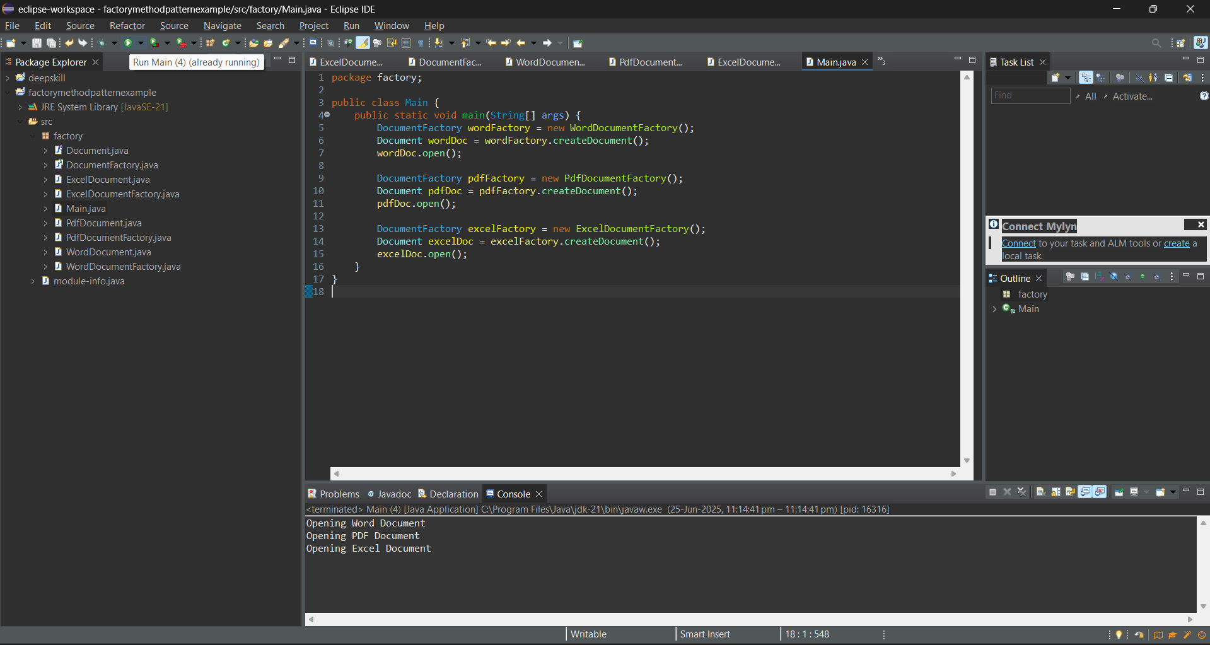

The output here is just to simulate the opening of the respective file by initiating and calling the functions for the file opening.